FA2 Chapter 7 – COS & Inventory Set 2
BPP PRK

FAIZ: PLEASE PUT THE QUESTION NUMBERS AS FA2-Inv-S2-01-PRK Q8.1

BPP PRK Q8.1
- In times of rising prices, the FIFO method of inventory valuation, when compared to the average cost method of inventory valuation, will usually result in which of the following?

- A higher profit and a lower closing inventory value
- A higher profit and a higher closing inventory value
- A lower profit and a lower closing inventory value
- A lower profit and a higher closing inventory value

The correct answer is:
B. A higher profit and a higher closing inventory value
Lower-valued inventory has been used in production and higher-valued inventory remains on hand.

BPP PRK Q8.2
- Derrek made an error when he calculated the value of his closing inventory, which means that the inventory is overvalued.

How are his profit for the year and net assets at the end of the year affected by this error?

Profit for the year Net assets
- Overstated Understated
- Overstated Overstated
- Understated Understated
- Understated Overstated

The correct answer is:
B. Profit for the year: Overstated; Net assets: Overstated
Both profit for the year and net assets have been overstated.

BPP PRK Q8.3
- Your organisation uses the continuous weighted average cost method of valuing inventories.

During August 20X1, the following inventory details were recorded:

Opening balance 30 units valued at $2 each
5 August Purchase of 50 units at $2.40 each
10 August Issue of 40 units
18 August Purchase of 60 units at $2.50 each
23 August Issue of 25 units

What is the value of the inventory at 31 August 20X1?

- $172.50
- $176.25
- $180.00
- $187.50

The correct answer is: C. $180.00

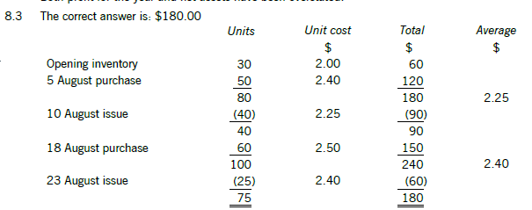

BPP PRK Q8.4
- During May 20X7, Huda's purchases were $126,500, and her sales were $150,000. Huda's gross profit was 20% of sales. The value of her inventory at 1 May 20X7 was $12,500.

What was the value of Huda's inventory at 31 May 20X7?
$ {2:NUMERICAL:=19000}

The correct answer is: $19,000
$
Opening inventory 12,500
Purchases 126,500
Sales at cost price (150,000 × 80%) (120,000)
Closing inventory 19,000

BPP PRK Q8.5
- Peter discovered that goods with a cost of $5,000 and a net realisable value of $3,000 have been omitted from the year-end inventory count.

What adjustment should be made to closing inventory?

- Increase of $5,000
- Increase of $3,000
- Increase of $2,000
- Decrease of $2,000

The correct answer is: B. Increase of $3,000
The inventory has been omitted, and must be included at its net realisable value of $3,000.

BPP PRK Q8.6
- Which method of inventory valuation is used when issues are assumed to be taken from inventory in the order in which they were received?

- Last in, first out
- First in, first out
- Periodic weighted average
- Continuous weighted average

The correct answer is: B. First in, first out

BPP PRK Q8.7
- At 30 June 20X2 Philip's inventory was measured at its cost of $45,400. This included items costing $2,600 which have since been superseded by an updated design. Philip will be able to sell these items through an agent for $1,400. The agent's commission will be 10% of selling price.

What was the correct value of closing inventory at 30 June 20X2?

- $45,400
- $44,200
- $44,060
- $42,800

The correct answer is: C. $44,060
$
Total sold at cost 45,400
Less obsolete inventory at cost (2,600)
42,800
Add net realisable value of obsolete inventory
Sales value 1,400
- 10% Commission (140)
1,260
Closing inventory 30 November 20X2 44,060

BPP PRK Q8.8
- Lavender measured her inventory at 31 December 20X2 at its cost of $11,480. This included some items which cost $975 which have been hard to sell. Lavender intends to have these items repacked at a cost of $225. This will allow her to sell them for $450.

What was the correct value of closing inventory at 31 December 20X2?
$ {2:NUMERICAL:=10730}

The correct answer is: $10,730.
The hard to sell items have a net realisable value of $450 – $225 = $225
So, the value of the closing inventory should have been:
$
Original 11,480
Less hard to sell inventory at cost (975)
Add NRV 225
Closing inventory at 31 December 20X2 10,730

BPP PRK Q8.9
- Which of the following is the correct formula to calculate cost of sales?

- Purchases – Opening inventory – Closing inventory
- Purchases + Opening inventory + Closing inventory
- Purchases – Opening inventory + Closing inventory
- Purchases + Opening inventory – Closing inventory

The correct answer is: D. Purchases + Opening inventory – Closing inventory

BPP PRK Q8.10
- Timmy has recently commenced trading. The materials he uses in his business are subject to regular price rises. He is unsure how to value his inventory and is trying to decide whether to use first in, first out (FIFO), or continuous weighted average.

Which of the following statements is correct?

- Timmy's profit will be unaffected by the method of inventory valuation.
- FIFO will lead to a higher reported profit.
- Continuous weighted average will lead to a higher reported profit.
- The profit figure will be more accurate if FIFO is used.

The correct answer is: B. FIFO will lead to a higher reported profit.
FIFO will lead to higher reported profit because his cost of sales will be based on the earliest (and therefore cheapest) purchases

BPP PRK Q8.11
- Monica sold some items of inventory for $1,950 in cash which she had bought for $2,622.

How are her assets and capital affected by the sale?

Assets Capital
- Reduced by $672 Reduced by $672
- Reduced by $2,622 Reduced by $672
- Increased by $672 Increased by $2,622
- Increased by $1,950 Reduced by $672

The correct answer is: Assets: A. Reduced by $672; Capital: Reduced by $672
One asset recorded at $2,622 (inventory) has been exchanged for another asset worth $1,950.
Therefore, both assets and capital are reduced by the difference of $672 ($2,622 – $1,950).

BPP PRK Q8.12
- The information below relates to inventory item Z.

March 1 50 units held in opening inventory at a cost of $40 per unit
March 17 50 units purchased at a cost of $50 per unit
March 31 60 units sold at a selling price of $100 per unit

Under the continuous weighted average cost method (AVCO), what is the value of inventory of item Z at 31 March?

- $4,000
- $1,800
- $2,000
- $2,500

The correct answer is: B. $1,800

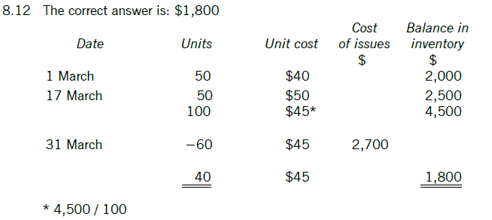

BPP PRK Q8.13
- A firm has the following transactions with its product R.

1 January 20X1 Opening inventory: nil
1 February 20X1 Buys 10 units at $300 per unit
11 February 20X1 Buys 12 units at $250 per unit
1 April 20X1 Sells 8 units at $400 per unit
1 August 20X1 Buys 6 units at $200 per unit
1 December 20X1 Sells 12 units at $400 per unit

The firm uses periodic weighted average cost (AVCO) to value its inventory. What is the inventory value at the end of the year?
$ {2:NUMERICAL:= $2,057.12}

Price per unit under periodic weighted average cost:
= Total cost /(opening quantity + total quantity received)
= ($300 × 10) + ($250 × 12) + ($200 × 6) / (0 + 10 + 12 + 6)
= $257.14 per unit.
Closing inventory of 8 units (10 + 12 – 8 + 6 – 12) × $257.14 = $2,057.12

BPP PRK Q8.14
- Duchovny's draft financial statements show a profit of $8,000 for the year ended 30 June 20X4.
Duchovny's inventories at 30 June 20X4 were measured at $25,000. This includes a quantity of product H, with a cost of $3,000, which is now obsolete. Duchovny expects to be able to sell product H during the year ended 30 June 20X5 for $1,200.

Which TWO of the following statements are correct?
(Examiner’s report, September 2022 to August 2023)

- Duchovny should write down inventories by $1,800 as an application of prudence
- Duchovny will record the loss in relation to product H in his financial statements for the year ended 30 June 20X5, when they are sold
- Closing inventories at 30 June 20X4 should be valued at $23,800
- Duchovny's adjusted profit for the year ended 30 June 20X4 should be $6,200

The correct answers are options:
- Duchovny should write down inventories by $1,800 as an application of prudence
- Duchovny's adjusted profit for the year ended 30 June 20X4 should be $6,200

The first option is correct. Inventories should be measured at the lower of cost and net realisable value in accordance with IAS 2 Inventories. This is an application of prudence as assets must not be overstated.

The fourth option is correct. Inventories must be adjusted by $1,800 ($3,000 - $1,200) to reflect the lower net realisable value of product H:
Dr Cost of sales (Statement of profit or loss)
Cr Inventories (Statement of financial position)

The adjustment in profit or loss is a debit entry and, therefore, profit will reduce (reflects the future loss expected on the sale of inventories).

Adjusted profit for the year is calculated as follows:
$
Draft profit 8,000
Inventories adjustment (1,800)
6,200
The second statement is incorrect as this does not apply the measurement criteria per IAS 2.
The third statement is incorrect. Inventories should be recorded as $23,200 ($25,000 – $1,800).

